**SQL Project – Restaurant Management System**

1. **Created Database and Used database for Creating table:**

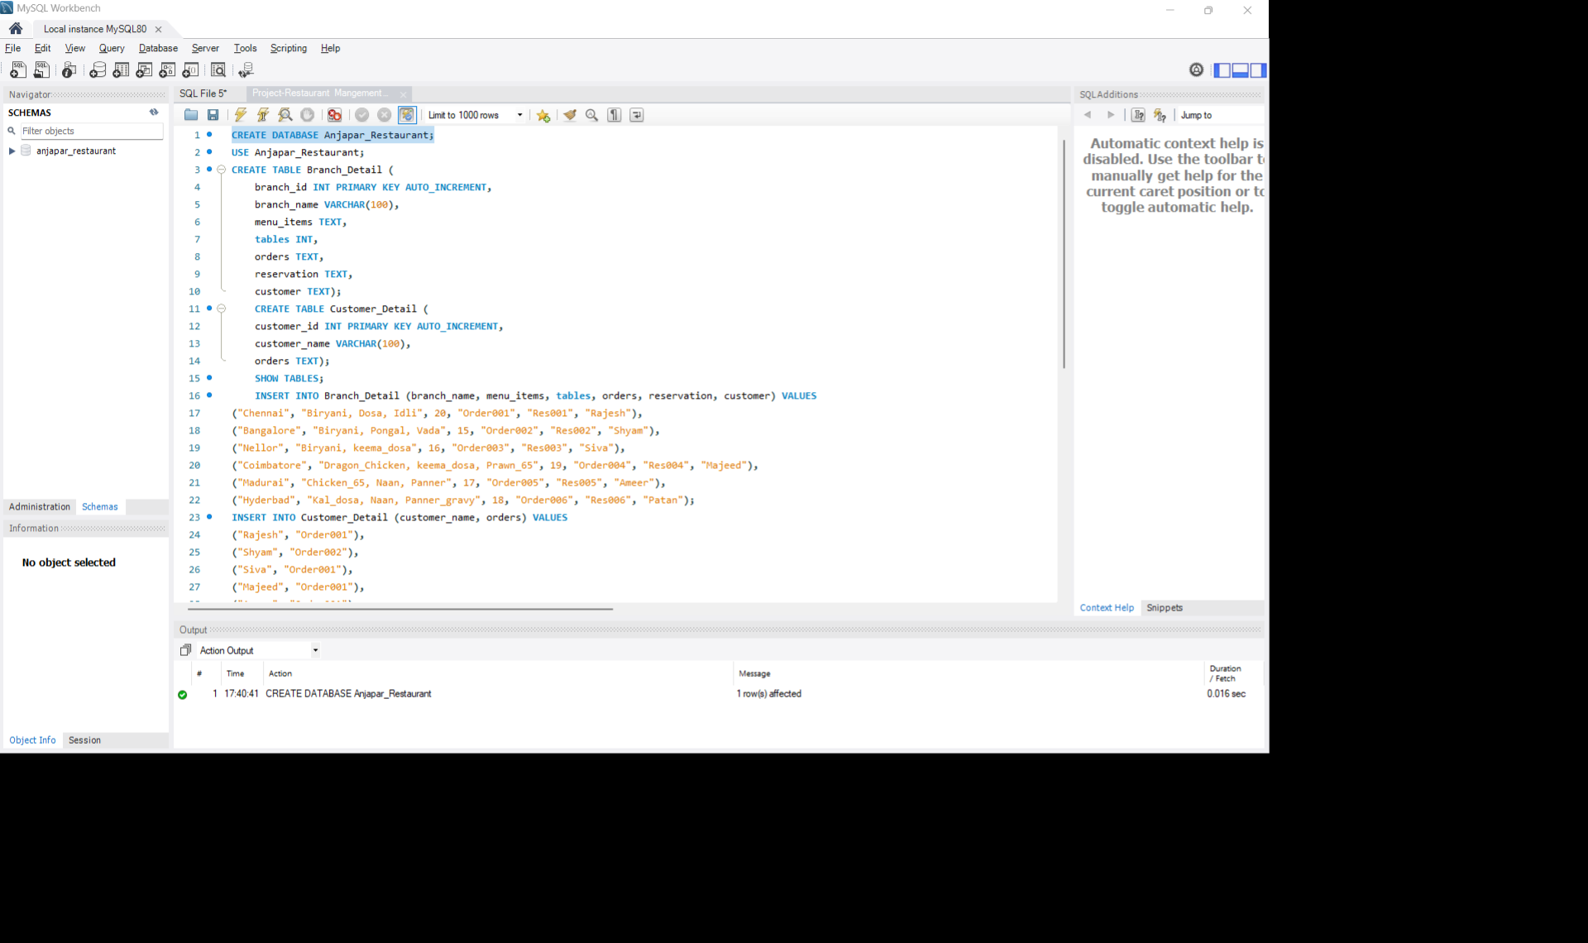

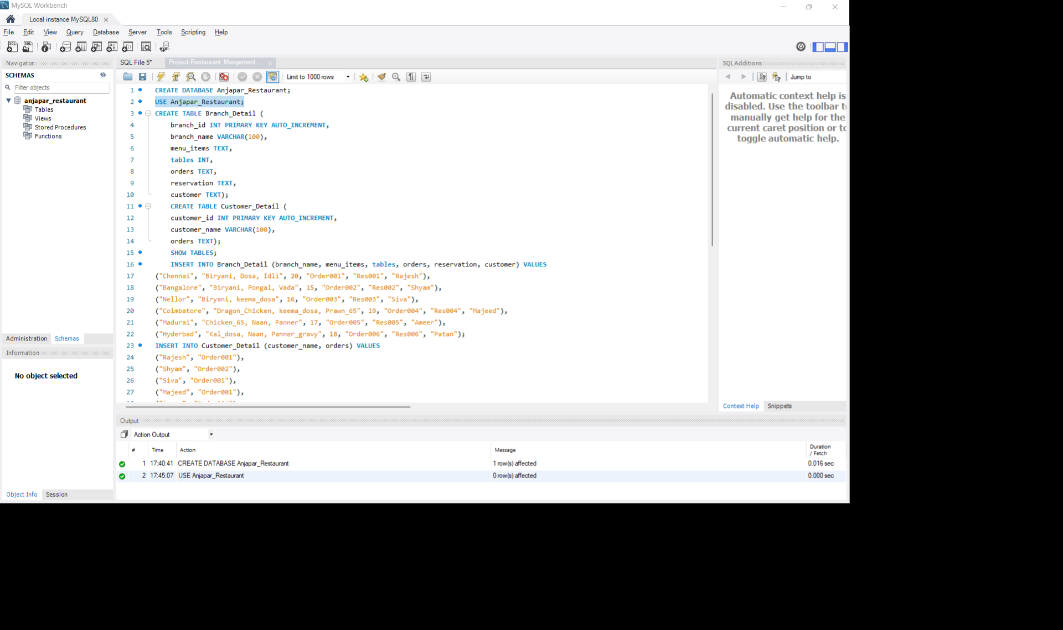

**2. Creating the Tables:**

*a) Branch_Detail Table (with menu, tables, orders, reservation, customer columns)*

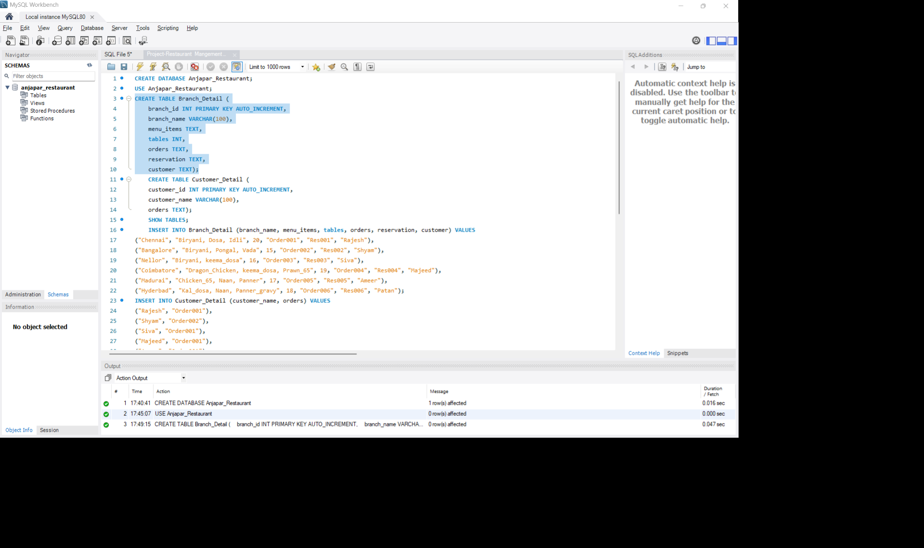

*b) Customer_Detail Table (with Customer_id, Customer_name, orders)*

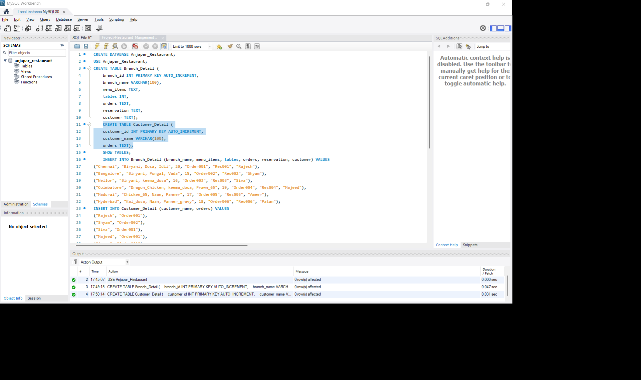

**3. Insert Sample Data**

*Insert into Branch_Detail*

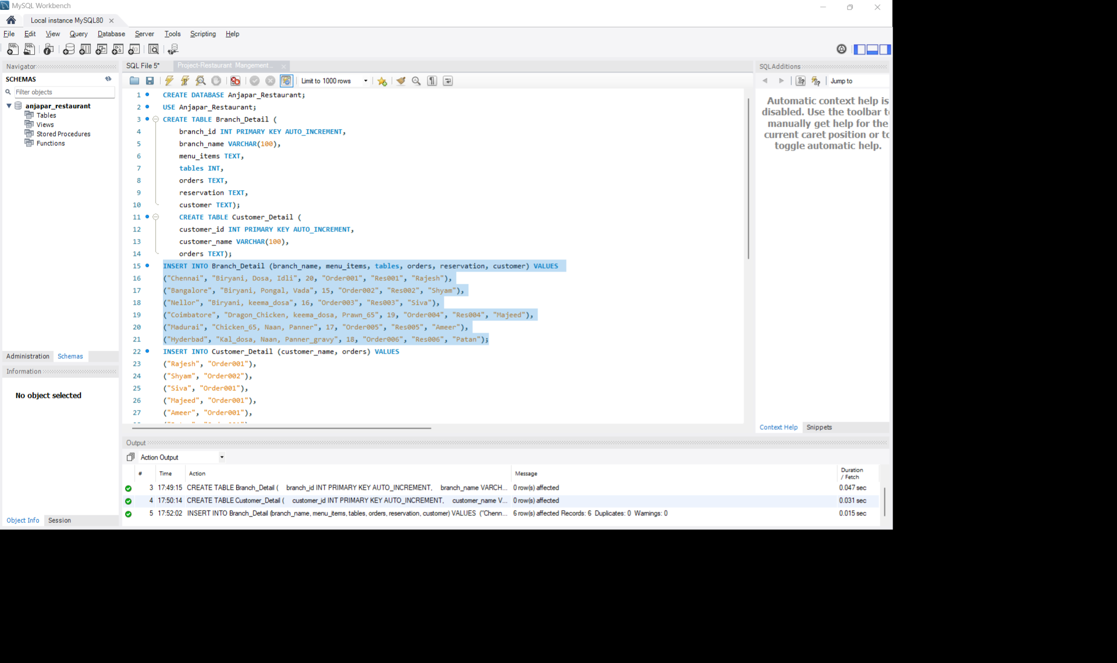

*Insert into Customer_Detail*

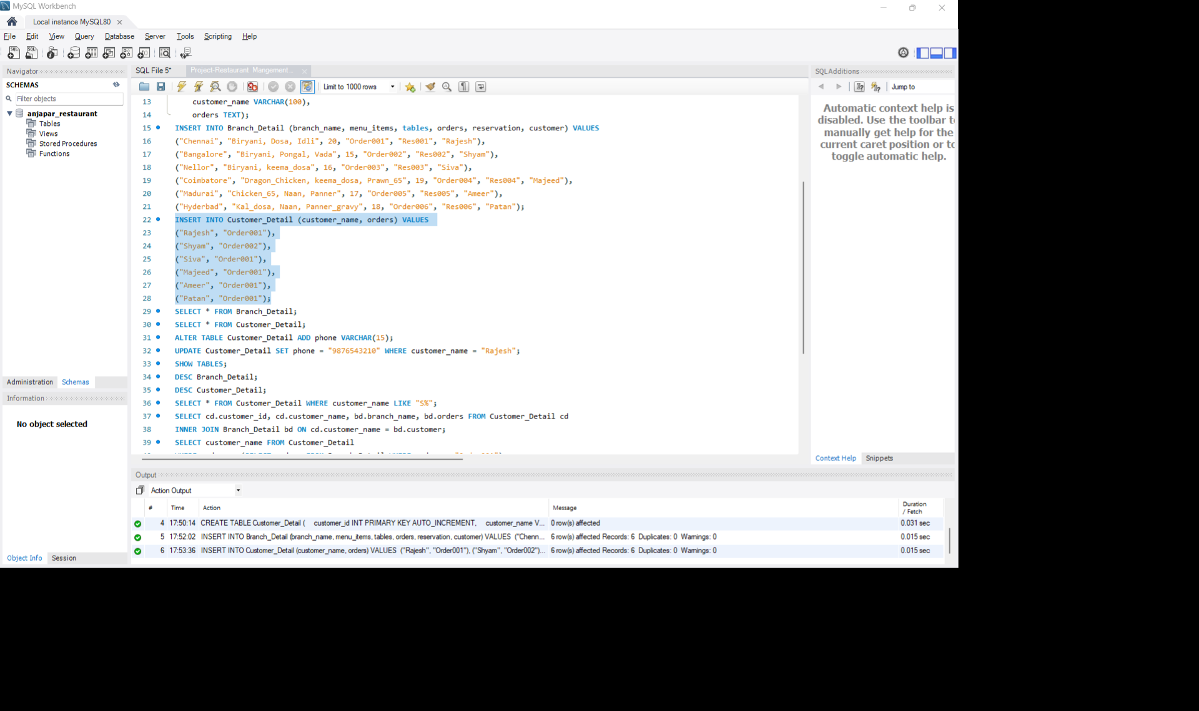

**4. SELECT Queries**

*View all branch details*

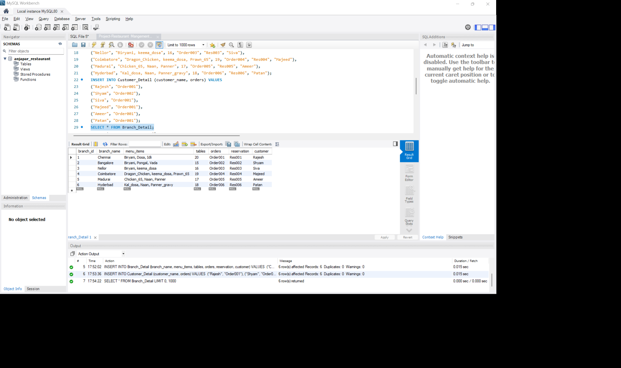

*View all customer details*

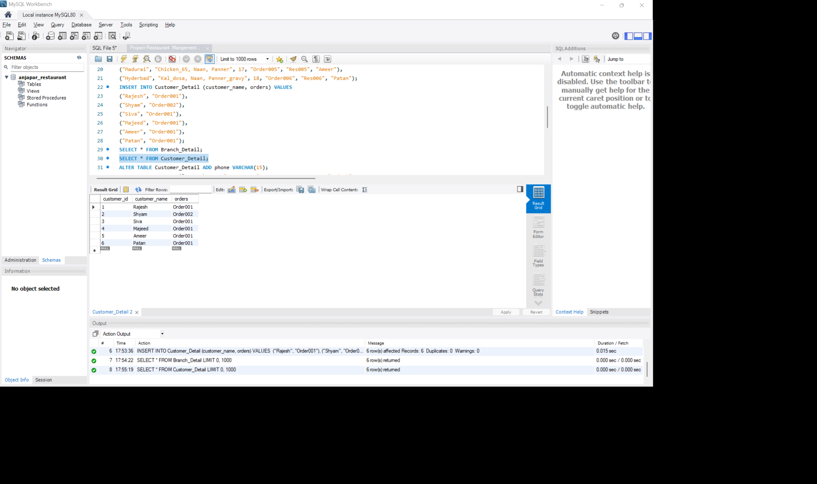

**5. ALTER Table**

*Add a phone column to Customer_Detail*

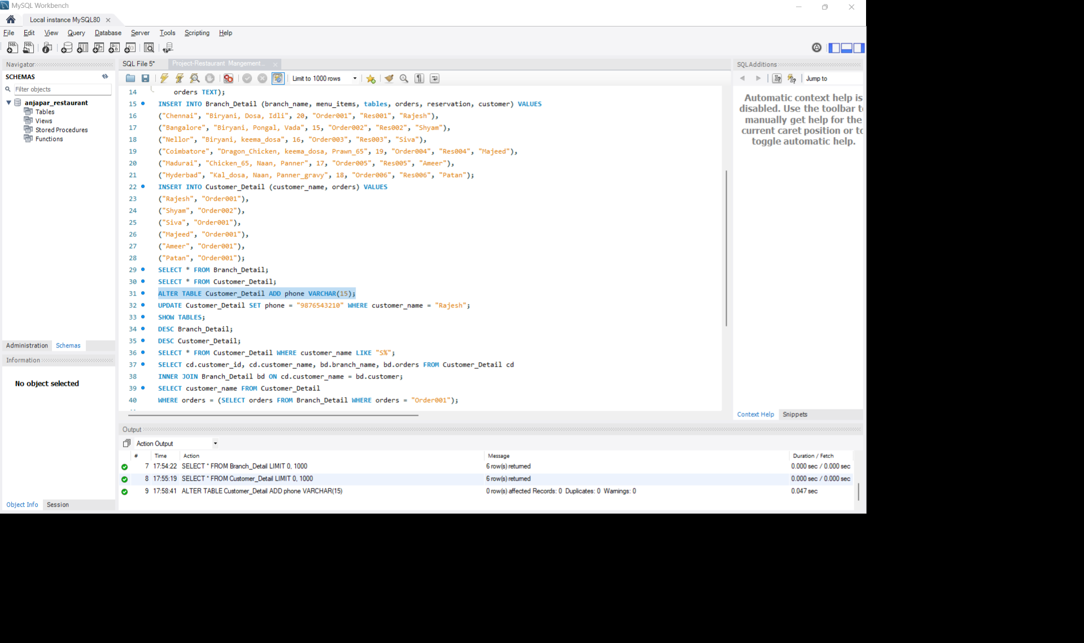

**6. UPDATE Query**

*Update phone number for customer Ram*

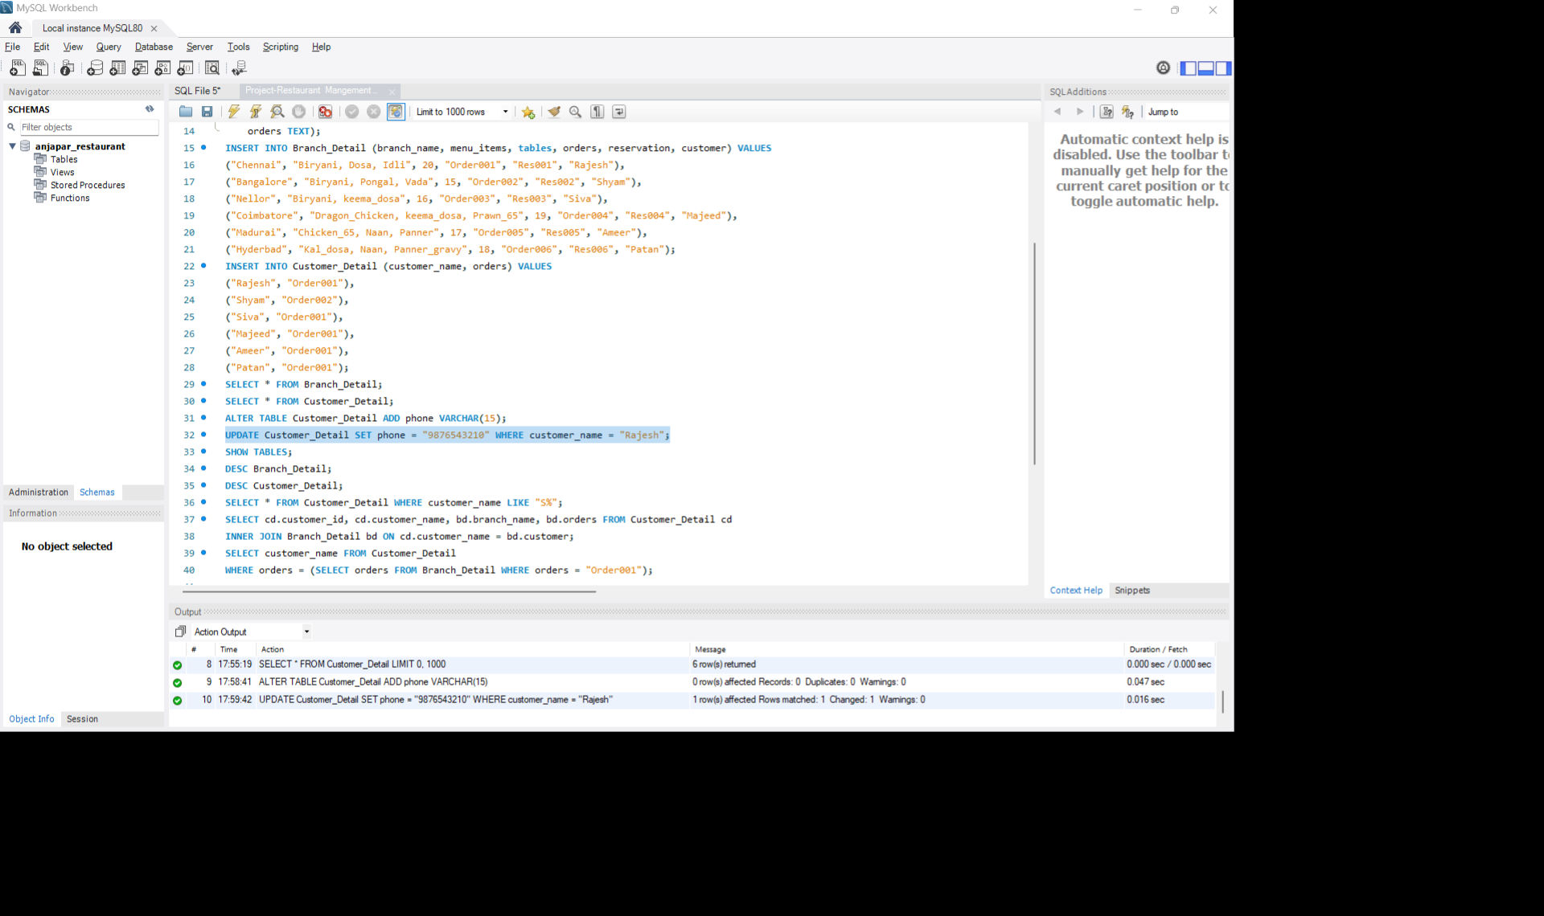

**7. SHOW and DESC**

*Describe table structure*

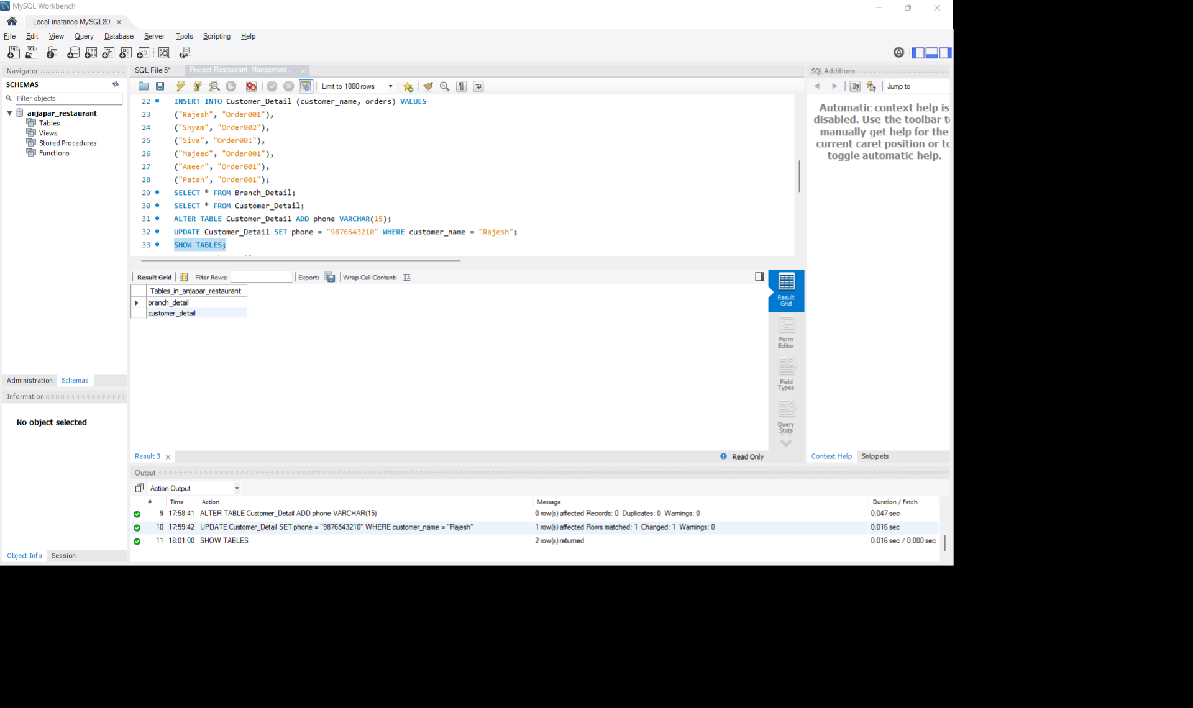

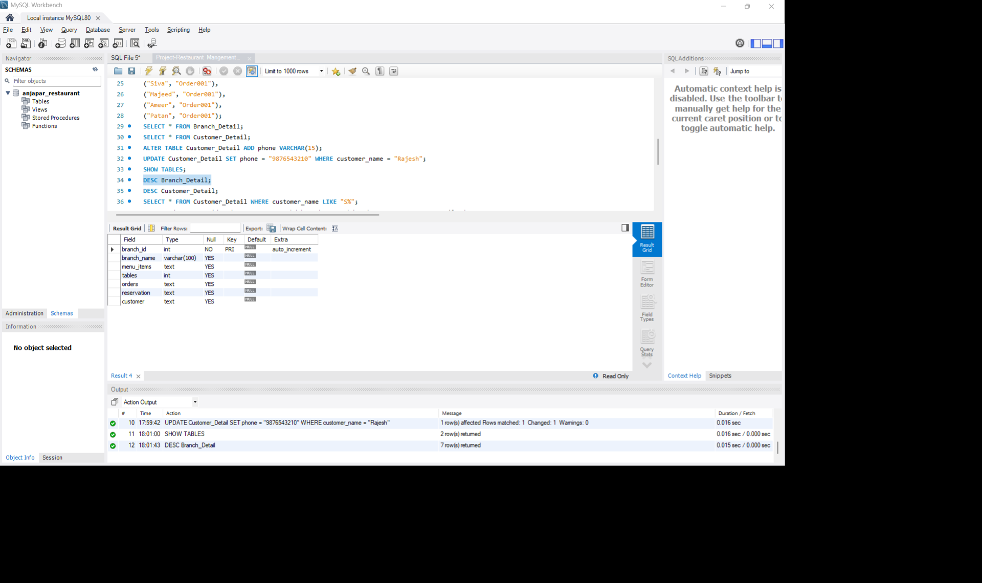

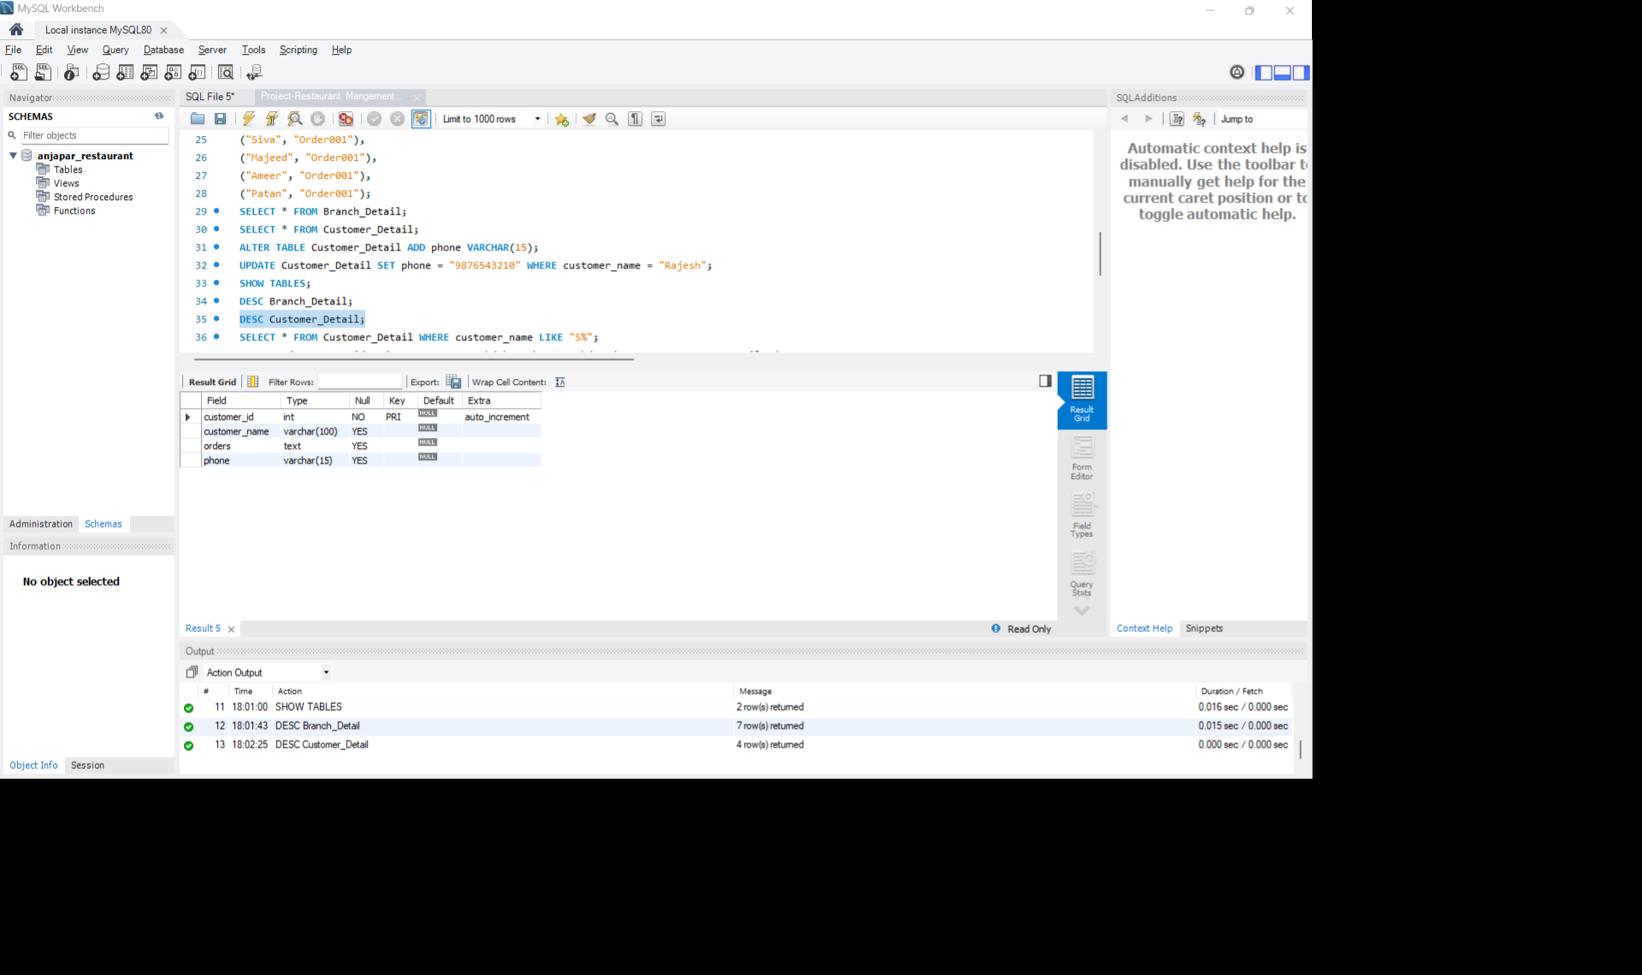

**8. WILDCARD Query**

*Search customer name starting with 'S'*

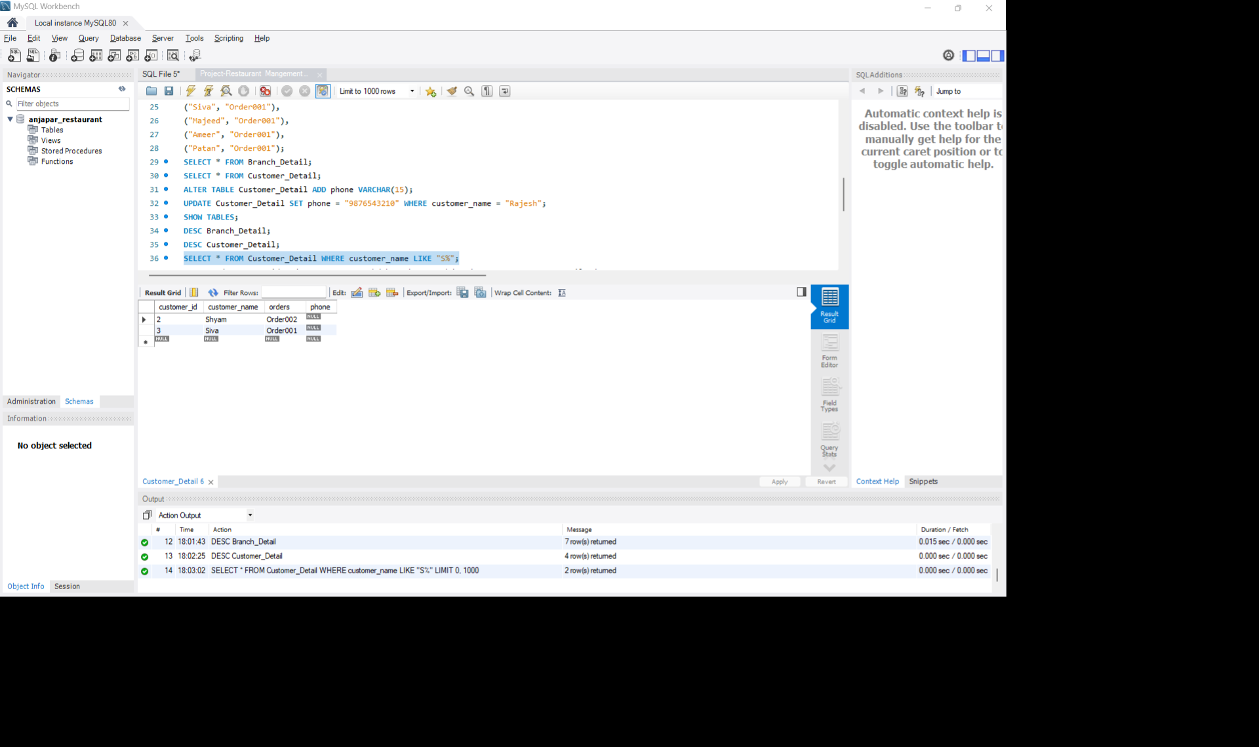

**9. INNER JOIN Example**

*Join to show customer with their branch orders*

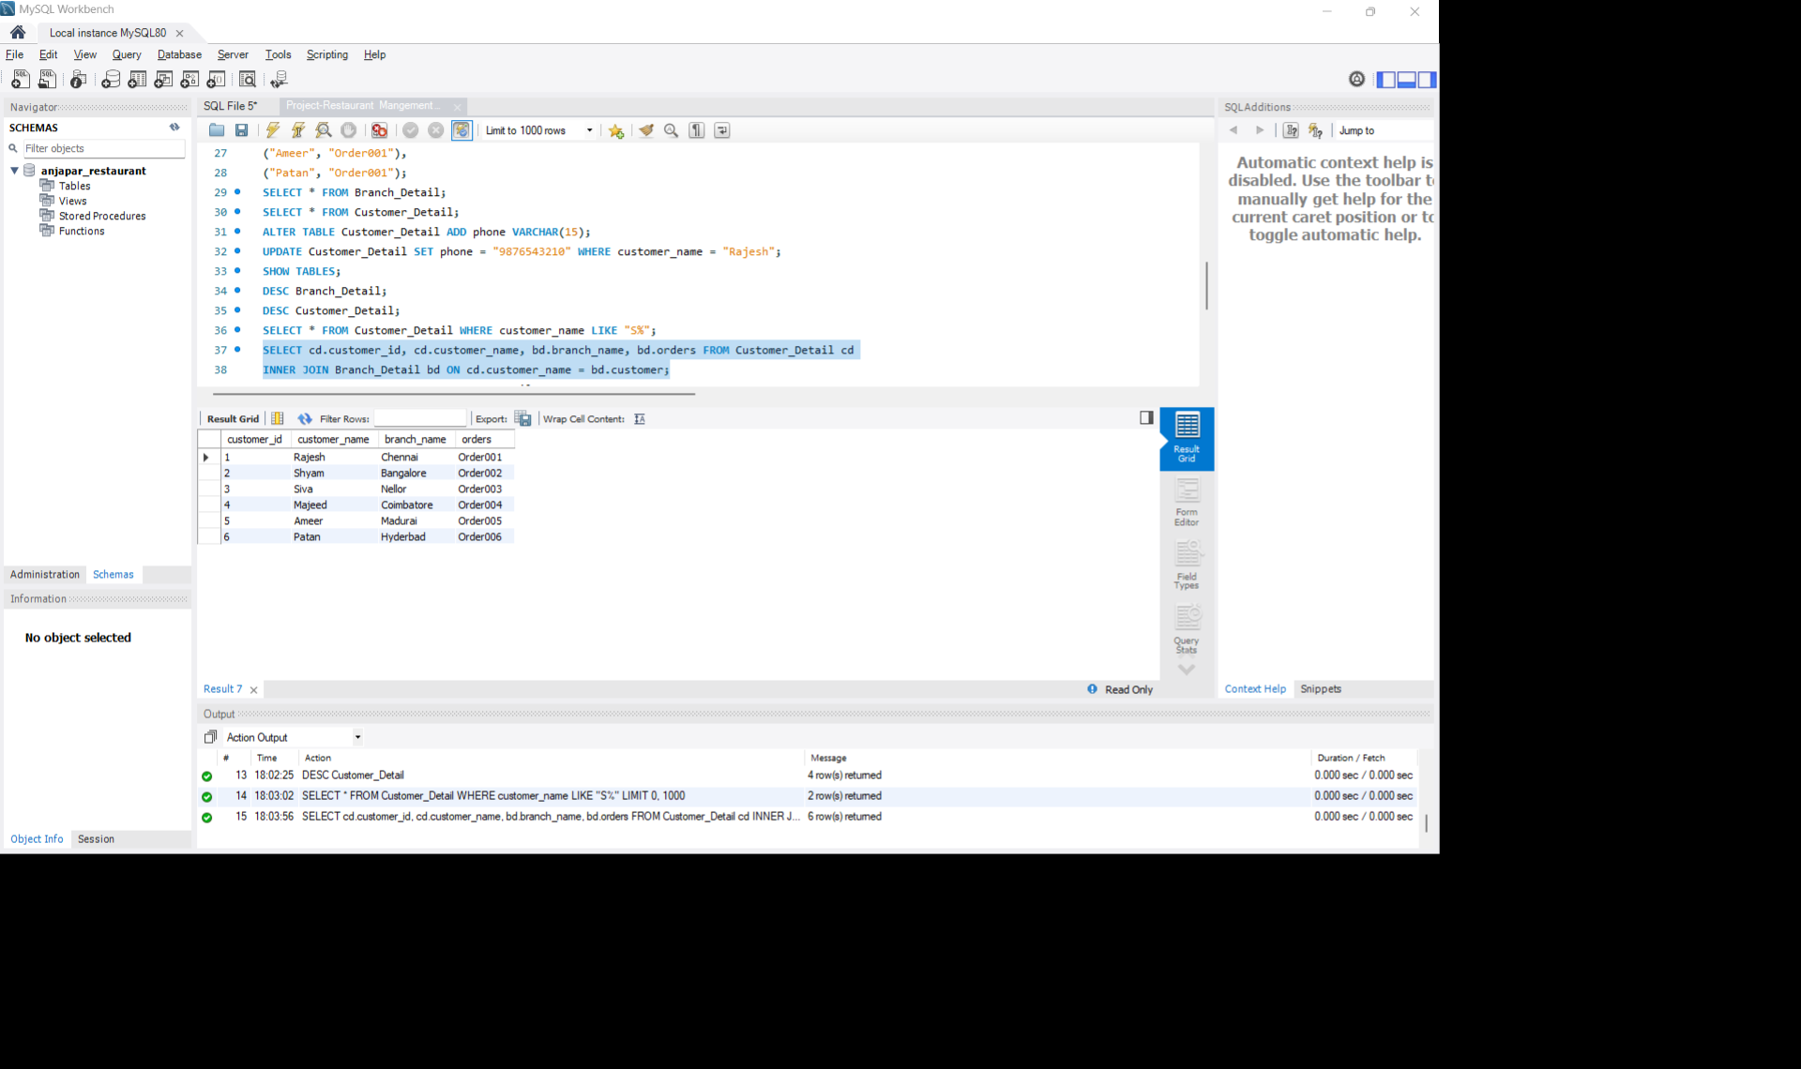

**10. SUBQUERY Example**

*Find customers who have placed 'Order001'*

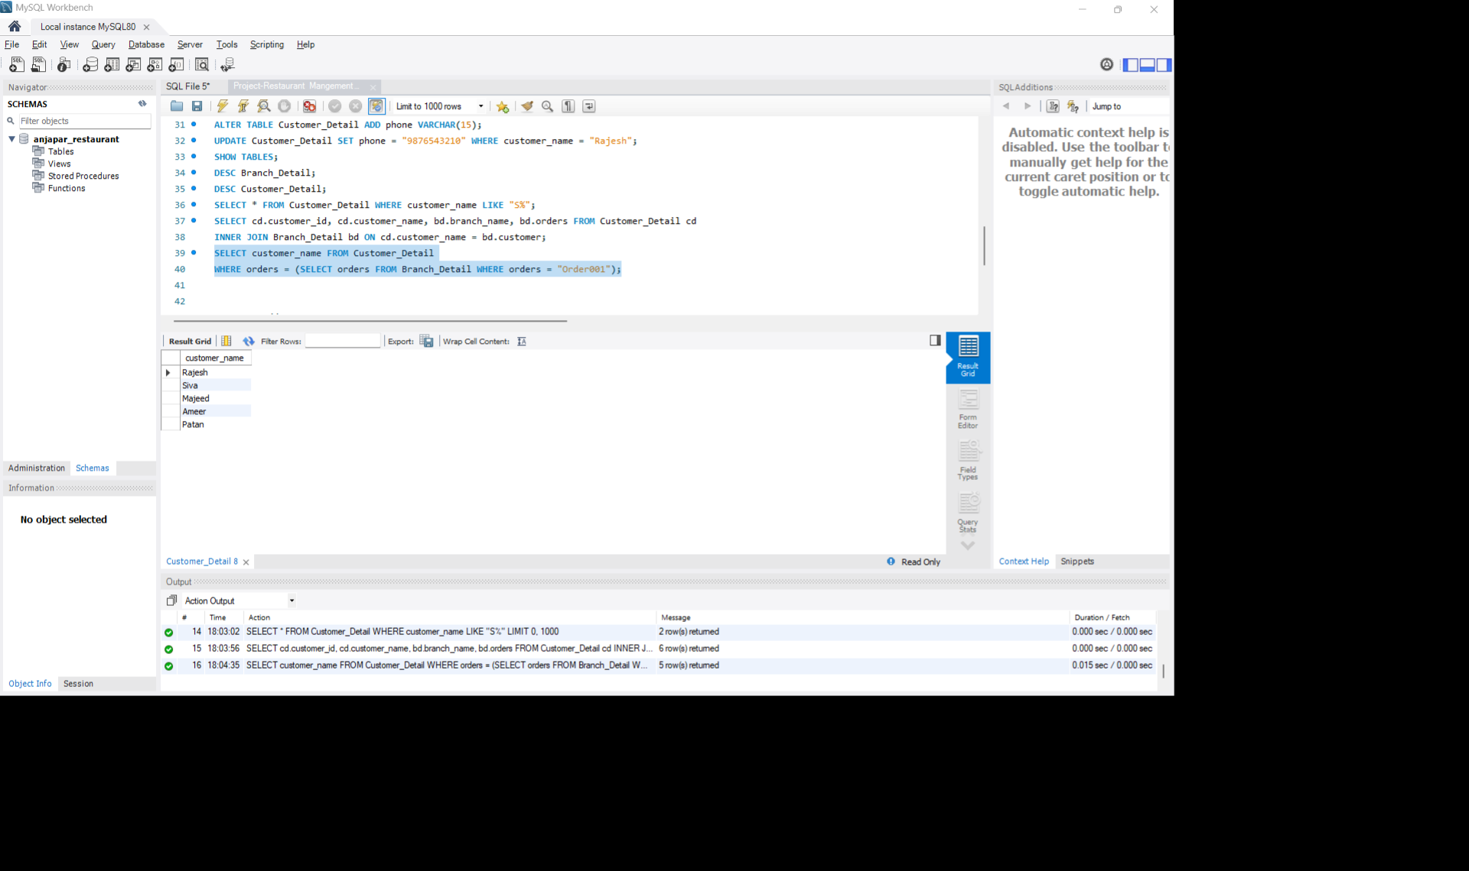

**11. STORED PROCEDURE**

*DELIMITER //*

